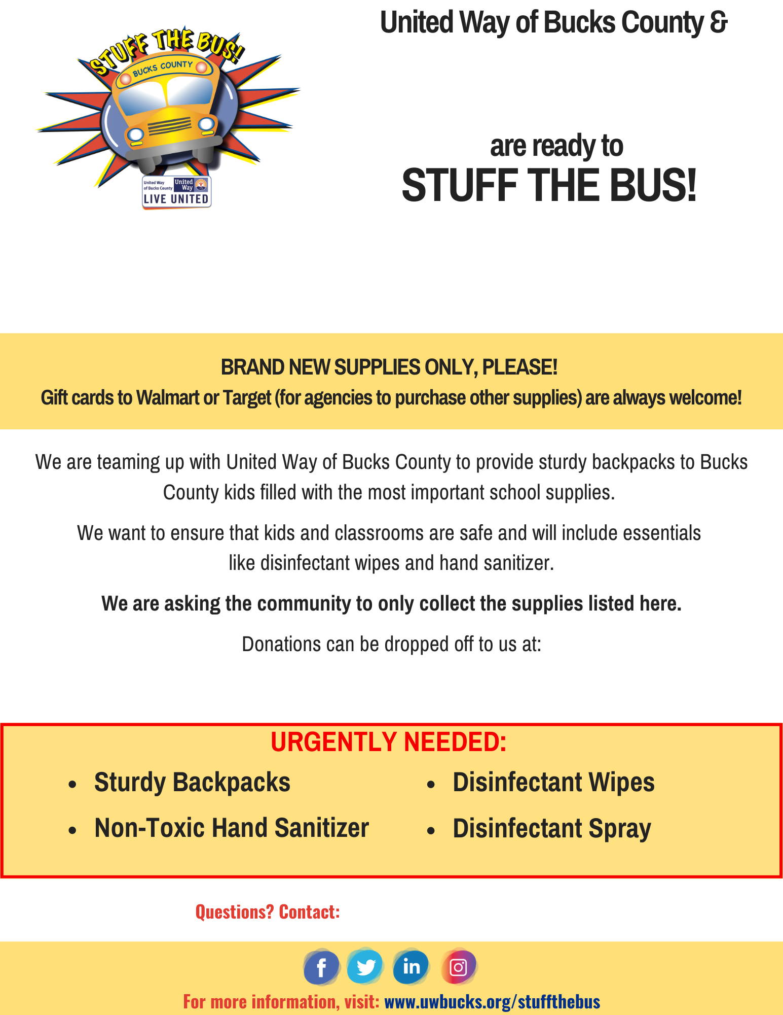

**Who do they contact with questions?**

**Where should people drop off supplies?**

**When are you collecting supplies?**

**Remember, UW Bucks needs your collected supplies by August 11-12.**

**Your company or group name goes here!**

**Insert your company or group name here!**

**Who do they contact with questions?**

**Where should people drop off supplies?**

**When are you collecting?**

**(Don't forget: UW Bucks needs all of your supplies by August 10th-11th!**

**Be sure to factor that in when you're picking your collection dates.)**